Stakeholder identification and engagement plan
The below information provides a guide to identifying the level of stakeholder engagement and methods of engagement.
Step one is to identify your key stakeholders, you can start to list them in a table, an example is provided below. Relevant stakeholders and other parties may include Elders, First Nations groups, landholders, community and/or environmental groups or organisations, Local Government Authorities, subcontractors, volunteers, etc. as appropriate to your area and project / activities.
Once you have identified your key stakeholders, you can use Figure 1 below to determine the impact or influence level of stakeholders so that you can identify appropriate methods of engagement, timings and who is responsible for the engagement activity. The stakeholder influence and impact level indicates the level of engagement. For example, medium influence and impact level stakeholders should be consulted through the project and you should work to build a good working relationship them and respond to any queries, it might be a good idea to have regular meetings with these groups or provide them with regular project updates via email or letter including when you reach important milestones.
Table 1: Stakeholder identification and engagement plan
Stakeholder | Key contact | Area of responsibility | Stakeholder key issues, interests, concerns and needs | Influence / impact level | Method of engagement | Timing | Project staff responsible
Organisation | Name, Position, and contact details | e.g. Unit Manager, Local Government Authority, landholder, Elder, etc. | e.g. Cultural knowledge transfer and retention, catchment care, etc. | Refer Figure 1 | e.g. Regular project meetings, stakeholder learning / working groups, quarterly updates via email or in-person meeting, etc | e.g. Ongoing / key milestones / specific project event (community planting day)

Impact / influence level of stakeholders
Q1 - Extreme (Collaborate)
Q2 - High (Involve and maintain confidence)
Q3 - Medium (Consult, monitor and respond)
Q4 - Low (Keep informed)
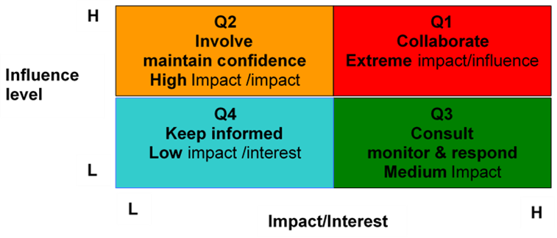
Figure 1 - Stakeholder engagement matrix
Definitions of the influence/ impact grid
Quadrants:
Q1 – COLLABORATE (High impact, High influence) - Stakeholders in this quadrant are highly influential on others and the outputs of our work will have significant impact on their future work processes and behaviours. The possibility of this group disrupting processes/projects is potentially very high. Communication will aim to involve them early, keep or develop them as allies, and will emphasise frequent personal contact and face-to-face communication.
Stakeholder impact/interest means the level of impact of the initiative on the stakeholder group and it can be categorised as:
- Extreme: these stakeholders are directly affected by the activity or outcomes and can / will determine whether the project succeeds or is stopped.
Q2 – INVOLVE AND MAINTAIN CONFIDENCE (Low impact, High influence) - Stakeholders in this quadrant have significant influence over others and therefore have the potential to disrupt the project. Therefore, it is particularly important to anticipate their objections and adverse reactions when planning communications. The change impact on them is lower so there is less need to involve them in day-to-day development and design activities. Rather, they will need to be involved in strategic decisions. Communication should aim to sustain and expand their support, but need not be as resource-intensive or frequent as the previous group as the need for them to change their behaviour is lower.
Stakeholder influence means the level of influence that the stakeholder group can assert on the project and can be categorised as:
- High: these stakeholders are capable of determining the success or otherwise of the project and are either impacted by the projects or its outcome or have a strong interest in the project or its deliverables.
Q3 – CONSULT, MONITOR AND RESPOND (High impact, Low influence) - Stakeholders in this quadrant will be significantly affected by the outputs of our work but have less influence over others and less potential to disrupt the project. Communication should be strongly proactive and pre-emptive, utilising more influential stakeholders from other quadrants, in particular “collaborate” to influence their acceptance.
Stakeholder influence means the level of influence that the stakeholder group can assert on the project and can be categorised as:
- Medium: the actions of these stakeholders could enhance or disrupt the project and they are moderately impacted by the project or its outcomes or have a medium level of interest.
Q4 - KEEP INFORMED (Low impact, Low influence) - Stakeholders who are neither highly influential nor greatly impacted by the changes but nonetheless have an interest in the outcomes, fall into this quadrant. Minimal communication activities are required, mass communications are usually sufficient and the main aim is to keep them informed to avoid potential problems.
Stakeholder influence means the level of influence that the stakeholder group can assert on the project and can be categorised as:
- Low: the actions of these stakeholders cannot affect or change the project outcomes and they require ongoing updates about project progress but aren’t necessarily directly impacted by the projects or its outcomes.

